IMPORTANT – before you start doing your solution, MUST do the following steps:

- Create your MS SQL database named PRJ311 by running code in script
PRJ311DB.sql.
- You MUST use DBContext.java for your all database connection.

Question 3: (4.0 Point)
Design the form might look something like figure below, named the java file is AOutcome.java (0.5 Point)
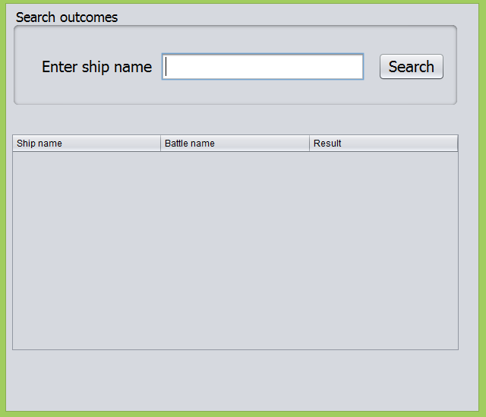
When users enter value for ship name and click Search button, output information of all outcomes in Outcomes table to below table which have ship name contains entered value (2.0 Point) also output the number of rows/records found (0.5 Point).
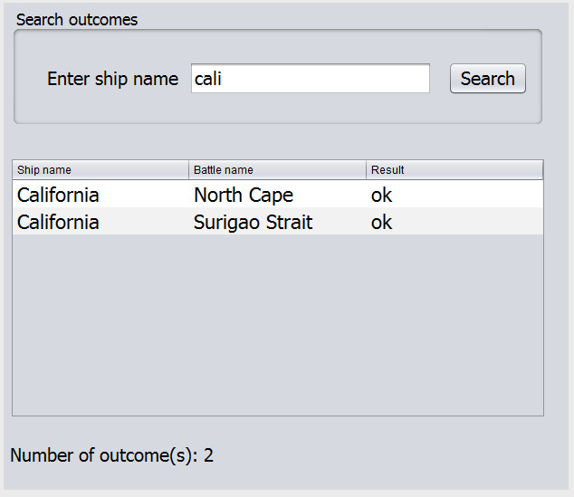

Output a message “Not found any Outcome” if the system could not find any matched Outcome (1.0 Point).
